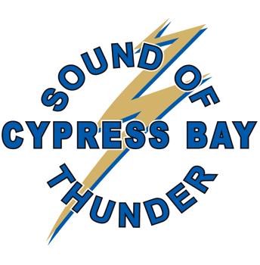
Sound of Thunder Bands Program
Cypress Bay High School
18600 Vista Park Blvd, Weston, FL 33332

Dear neighbors and members of the local business community,

We are writing you about a sponsorship opportunity with the Cypress Bay High School “Sound of Thunder Bands Program.” We understand that you have a desire to give back to your local community. In years past, the indispensable support of organizations like yours have helped the musicians in our program participate in the different events and activities that enhance their growth and experience in the music program.

Our marching band is composed of almost 100 energetic and competitive musicians and color guard students. The marching band attends various local events throughout the year and attends competitions in October and November, ending the marching season at a state-level competition, Florida Marching Band Championships (“FMBC”), on November 11-12, 2023. The marching season is followed by the Winter and Spring 2024 concert seasons.

This upcoming school year the Sound of Thunder Bands Program looks to build on the extraordinary success of the last few seasons, where they earned the prestigious Otto J. Kraushaar Award for the 3rd time in Cypress Bay’s history. The Otto J. Kraushaar Award is given out at the end of the school year to those select band programs that were awarded Superior ratings from every judge for Marching and Concert at the numerous District and State level competitions throughout the year.

In addition, in recent years, our concert bands have been invited to participate in competitions such as “Orlando Fest” (Symphonic Band) in Orlando, Florida, “Music for All” (Wind Ensemble) in Indianapolis, Indiana and “JanFest” (Wind Ensemble) at the University of Georgia January High School Band Festival.

Your sponsorship is an important component of our students’ success and contributes directly to one of the premier music programs in the state of Florida. Sponsorship will help cover travel-related costs, meals, lodging, uniforms, props and fees to attend competitions. We have several sponsorship levels from which to choose. We are enclosing the sponsorship brochure which describes the different sponsorship amounts and the corresponding recognition given to sponsors at each level.

We greatly appreciate your support for your local high school band program. This will be a great opportunity to give back to your community while promoting your business or organization through not only the Marching season, but also during our Winter and Spring concert season.

Please consider making this crucial commitment as a 2023-2024 Sound of Thunder Bands Program sponsor during this month of August as we plan for the year ahead! Feel free to contact us with any questions at communityoutreach@cbbpa.org.

Sincerely,

Cypress Bay Band Parent Association (CBBPA)

